Project Design Phase-II Technology Stack (Architecture & Stack)

|  |  |
| --- | --- |
| Team ID | PNT2022TMID330639 |
| Project Name | Project-IOT Based Safety Gadget for Child  Safety Monitoring and Notification |
| Maximum Marks | 4 Marks |

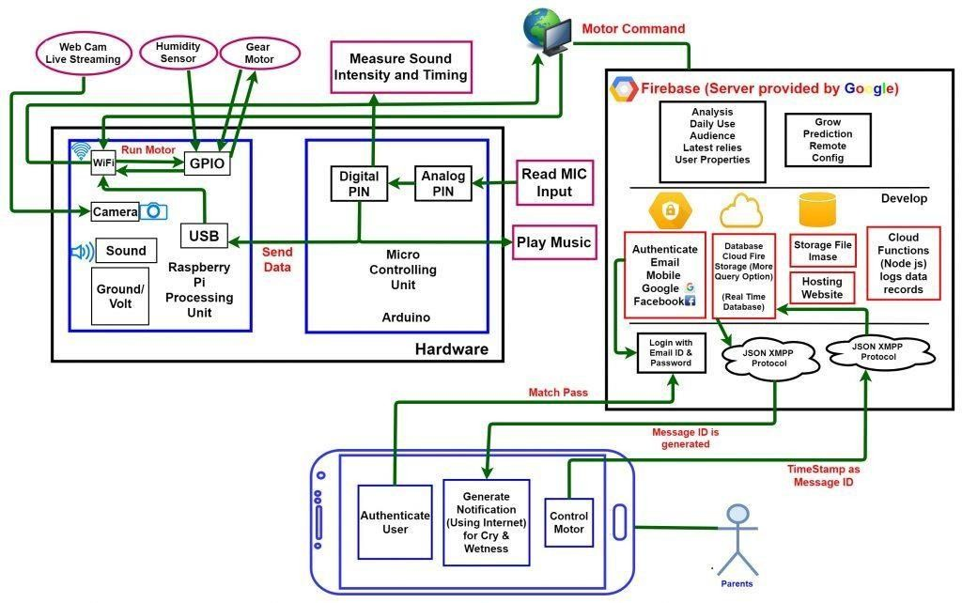

Table-1 : Components & Technologies:

|  |  |  |  |
| --- | --- | --- | --- |
| **S .No** | **Component** | **Description** | **Technology** |
| 1. | User Interface | .Web UI, Mobile App. | HTML, CSS, JavaScript |
| 2. | Application Logic-1 | Code development phase | Python |
| 3. | Application Logic-2 | Interfacing purpose | IBM Watson Assistant |
| 4. | Cloud Database | Database Service on Cloud | IBM Cloudant |
| 5. | File Storage | Usage of IBM Cloud Storage | IBM Block Storage |
| 6. | Browser based flow editor | Visual programming | Node Red |
| 7. | Infrastructure (server/cloud) | Application deployment on Local Server | Cloud Platform |

Table-2: Application Characteristics:

|  |  |  |  |
| --- | --- | --- | --- |
| **S .No** | **Characteristics** | **Description** | **Technology** |
| 1. | Open-Source Frameworks | A template for software development that is  designed by social network | IBM Watson Platform, Node Red |
| 2. | Security Implementations | Each and every parent should take care of their own children, without letting them to fall into the dark world of abuses, which entirely ruin them physically, mentally and emotionally destroying our future. Hence, considering the importance of our future, our project makes it easy for parents to track their children and to visually monitor them on regular Basis, which makes them ensure the safety of their children and reduces | Notifications and alerts |
| 3. | Scalable Architecture | the rate of incidents of child abuse. If any abnormal values are read by the sensor, then an SMS is sent to the parents mobile and an MMS indicating an image captured  by the serial camera is also sent. The future scope of the work is to implement the loT | Implementation using Software |

|  |  |  |  |
| --- | --- | --- | --- |
|  |  | device which ensures the complete solution for child safety problems. |  |
| 4. | Availability | The solution represented takes advantage of  Open- source Platform | NODE RED, IBM cloud, IBM Iot  Platform |
| 5. | Performance | GPS is useful for tracking child and GPS also provides the information where the child is currently located as well as it also informs the parents how long his child is far away from his parents. SMS services used when smart phones do not support internet connectivity in this case child is able to send a text message or exact location in the parents. This system is going to help the parents to track the location of their children without informing them because their movement is displayed on the parent's phone. | GPS |